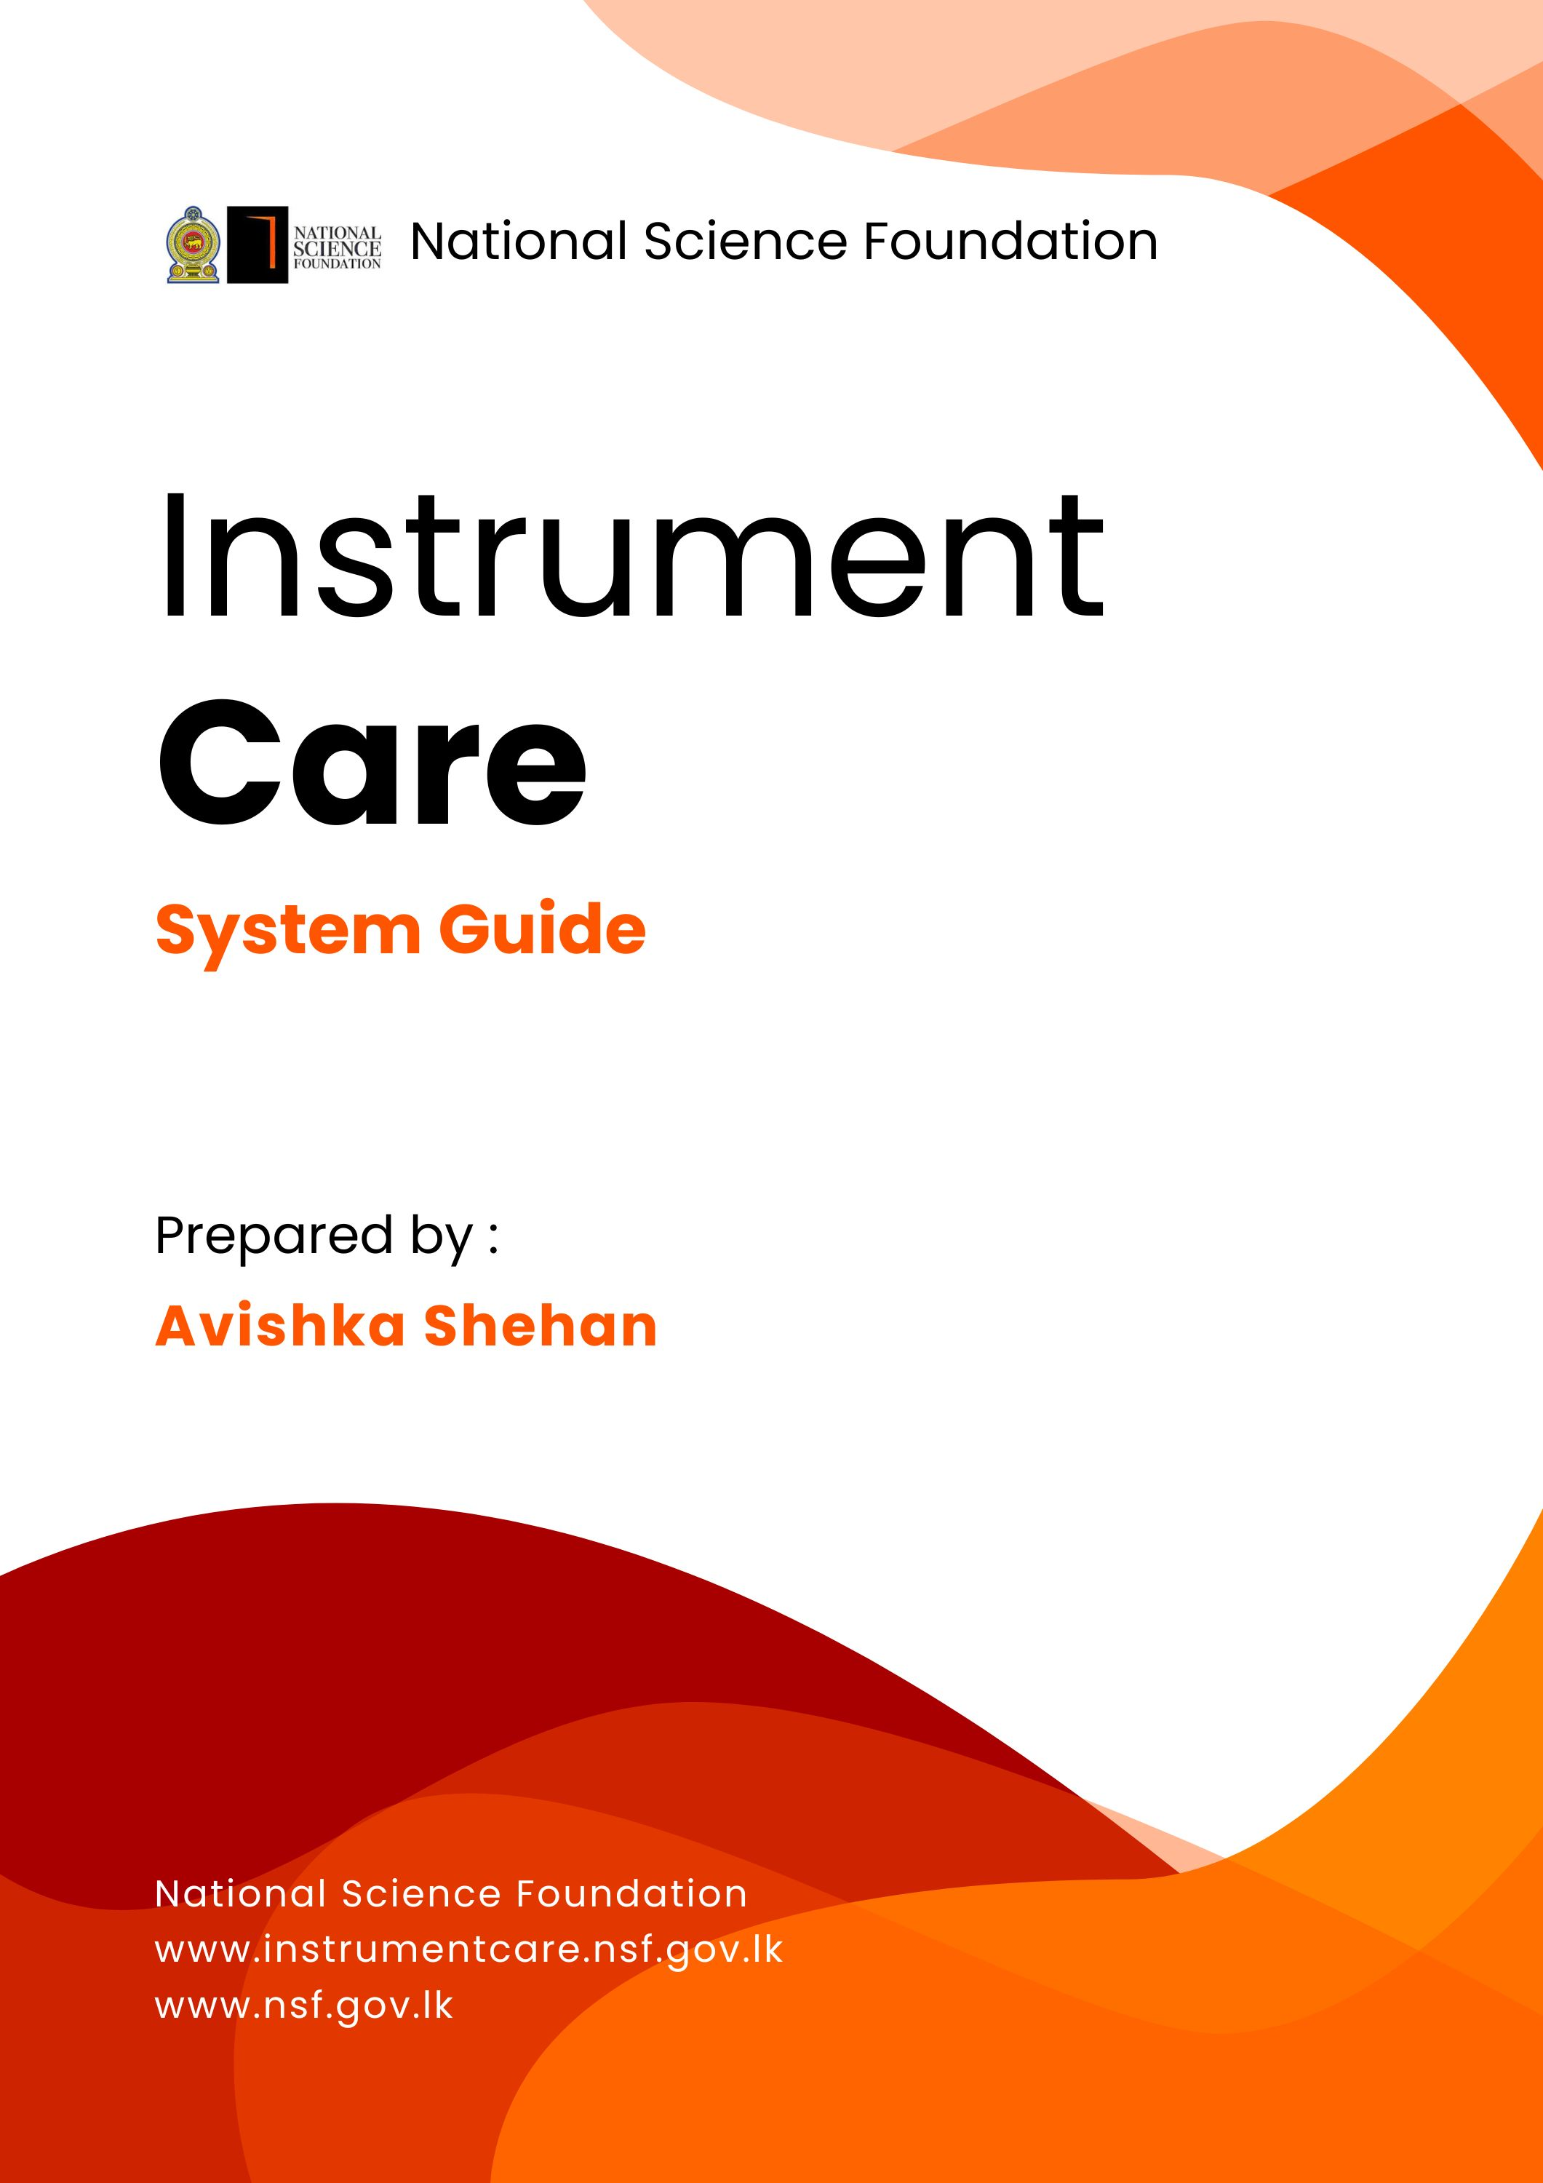


Home Page
Go to Technician
Registration Page
Go to Login Page
Go to Contact Page
Go to Technician Page
Go to About Page
Go to Home Page

Go to Login Page
Go to Technician Page
Redirected to login page
If you are already logged in then it redirected to the technician page inside the system. If you not log in then it shows login page.

Go to Technician Page
If you are already logged in then it redirected to the technician page inside the system. If you not log in then it shows login page.

Go to Technician Page
If you are already logged in then it redirected to the technician page inside the system. If you not log in then it shows login page.


About Page


Technician Page

Contact Page


Login Page



Technician Registration Page



